**Instruction:**

Complete all questions in **1 hour.**

1. The table below shows the Truth table of Half Subtractor, write SOP expression for difference and borrow and design the circuit using Logsim.

|  |  |  |  |
| --- | --- | --- | --- |
| **A** | **B** | **Difference** | **Borrow** |
| **0** | **0** | **0** | **0** |
| **0** | **1** | **1** | **1** |
| **1** | **0** | **1** | **0** |
| **1** | **1** | **0** | **0** |

*Difference= A’.B+A.B’*

*Borrow =A’.B*

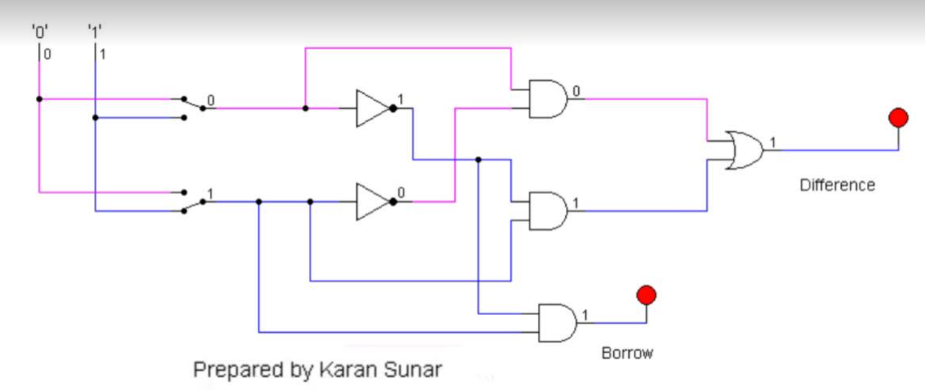

Design 2:4 decoder using logsim and Construct Truth table.

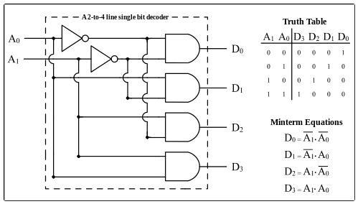

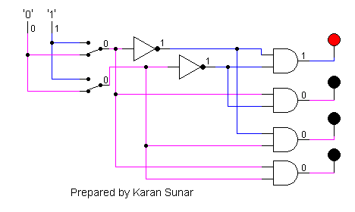

1. Draw the following simple ALU circuit using Logsim and describe the outputs when instructions are 1 and 0.

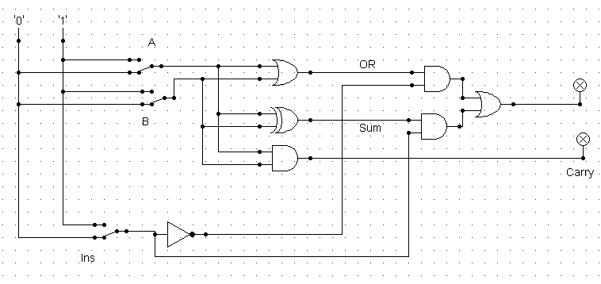

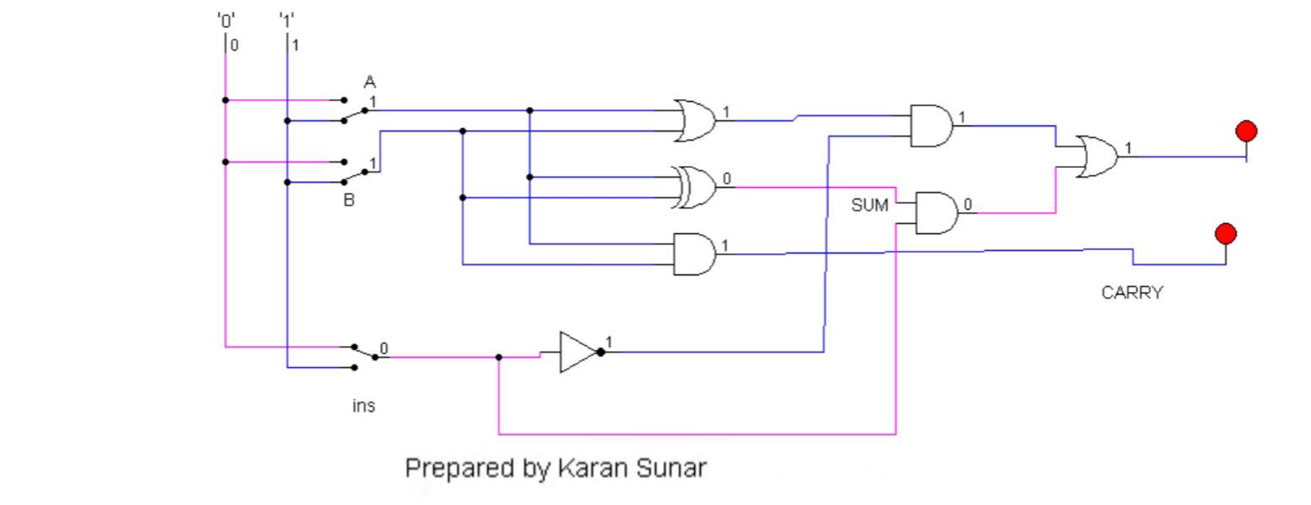

When the ins is 0, it gets inverted to 1 and passes through AND gate and hence the light glows. 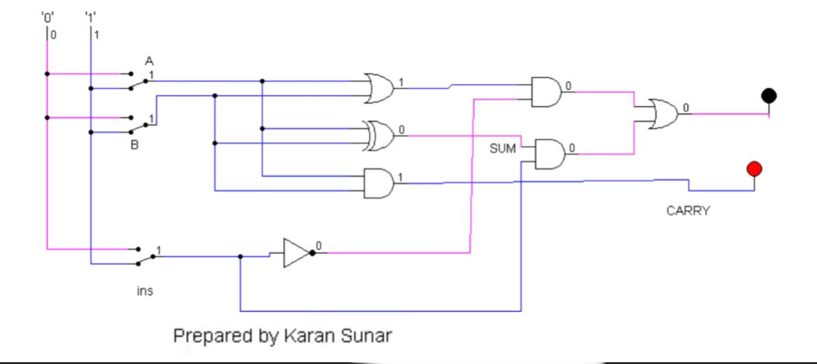

When ins is 1, it gets inverted to 0 and passes through the AND gate. As both are 0 the light doesnt glow.

1. Write sort notes on the following topic:

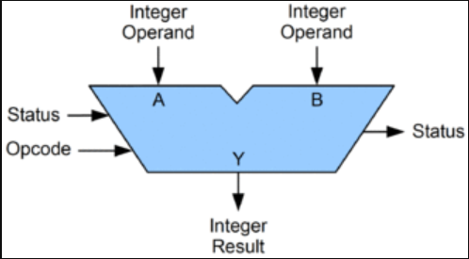

1. ALU

Arithmetic Logical Unit (ALU) is a functional

unit containing logical blocks. It performs a

set of arithmetic operations and a set of

logical operations. It selects the required

output according to the instruction.

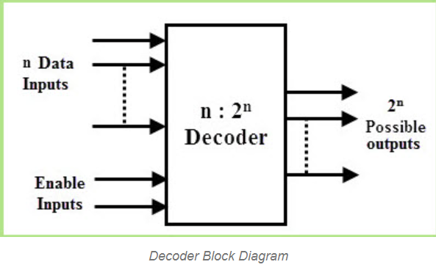

1. Decoder

Decoder is a part of the Arithmetic Logic Unit

that always takes positive input. It can be also

called a combinational logic circuit. The output

always depends on the input and has multiple

output lines. With the combination of decoders

we can create a multiplexer.

1. 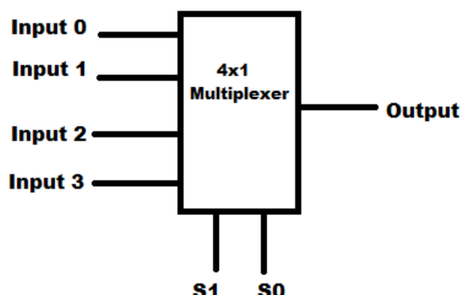Multiplexer

Multiplexer, also commonly known as MUX in

short form, is the collection of AND gates

connected to an OR gate. As there are many

inputs in the multiplexer and has only one

output it results with the assistance a decoder.